Personal stories of religious discrimination
Everyone deserves to work, study and live with dignity and respect. The Victorian Equal Opportunity (Religious Exceptions) Amendment Bill 2021 narrows outdated carve-outs that currently allow faith-based schools and organisations to discriminate against LGBTQ+ workers, students and people who rely on their support, among others.
Equality Australia has been given permission to share the stories of people who have experienced discrimination because of these outdated laws.

Teacher: Rachel Colvin
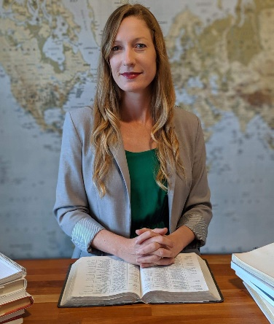
Mrs Rachel Colvin, a committed Christian and married mother of three, had a 10-year unblemished teaching record at Ballarat Christian College, a non-denominational Christian school.
After the 2017 marriage plebiscite, the College amended its policy to require all its employees to agree with and abide by a statement that ‘marriage can only be between a male and a female’. Mrs Colvin refused to sign the statement that contradicted her own Christian and political beliefs which were affirming of LGBTIQ+ people.
Mrs Colvin was refused teaching and development opportunities, subjected to counselling and ultimately forced to resign by the school.
Under these proposed laws, schools like Ballarat Christian College would need to show that holding a religious belief that ‘marriage only be between a man and a woman’ was essential to Mrs Colvin’s role as an English teacher, and that it was reasonable and proportionate for the school to enforce that belief, especially in circumstances where Mrs Colvin was willing to remain silent about her beliefs with her students.

Student: Evie Macdonald

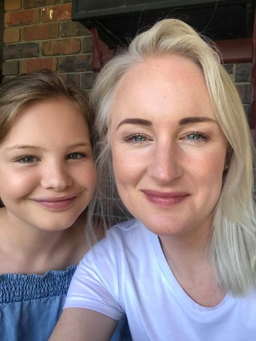
Evie Macdonald is a 16-year-old transgender girl. In 2020, Evie made her acting debut in the ground-breaking ABC children’s series, First Day, which recently won an Emmy.

Between 2011 and 2015, Evie attended a religious school in the Mornington Peninsula. In 2015, when she was 10 years old, her teacher asked the class to divide into separate groups of girls and boys. When Evie said she wanted to go with the female students, her teacher refused and told her that she was a boy, and physically dragged her towards the group of male students.

In 2015, without her parents’ knowledge, Evie was made to attend seven sessions of chaplaincy counselling by the school, designed to prevent her affirming her gender as a girl. When Evie’s mother, Meagan, found out, she was furious. Evie’s parents removed her from the school as soon as they could get placement at another school.
Under these proposed laws, schools like Evie’s former school could no longer expel or treat unfairly a student who came out as trans or gay. But the Bill should go further and ensure schools cannot impose discriminatory standards of dress, appearance or behaviour on their students.

Teacher: Sam Cairns
For 7 years, Sam Cairns worked at Flinders Christian College, a non-denominational Christian school. Sam was herself a graduate of the school.
When Sam came to terms with her sexuality, she assumed that the school would not accept her being open about who she was. In 2011, she reluctantly decided to resign.
In 2012, after finding it hard to find work, the school welcomed Sam back as a relief teacher and then on a short-term contract to teach computing studies, geography and history. But on the first day of her contract, Sam was called into the Vice Principal’s office and told to immediately pack her things as the school had been ‘made aware’ of her ‘choice of sexuality’.
Under these proposed laws, teachers in a similar position to Sam’s could not be fired simply because of their sexuality or gender identity.

Service user: Harley
In 2015, Harley fled intimate partner and family violence, seeking accommodation at a refuge provided by a faith-based organisation.
During their time at the refuge, they were counselled against disclosing their sexuality or wearing rainbow items of clothing. They were told they were ‘going to hell’ by a staff member who said they would ‘pray for God to show them the way’. Harley left the refuge and spent three nights sleeping on the streets instead.
In 2021, Harley and their wife sought emergency accommodation from a different faith-based organisation. This time, Harley’s wife (who is a transwoman) was told that she would need to go to a men’s shelter rather than access the same facility as Harley.
Under these proposed laws, faith-based service providers will not be permitted to discriminate on the basis of sexual orientation or gender identity when they deliver Victorian Government-funded goods, services or accommodation. Where goods, services or accommodation are funded privately or by the Commonwealth, faith-based organisations will be able to discriminate when it is reasonable and proportionate to do so.

Retired principal: John Connors
John Connors retired 2 years ago, after 37 years in Catholic education – 20 years of which were as principal. John taught in several schools.
John hid his sexuality throughout his 37-year career. For example, when John and his partner moved into a new home together, he hid his excitement from his colleagues. John always feared being sacked if his sexuality ever became general knowledge.
Despite his attempts to keep his sexuality private, there were still a few close calls. The souring of a previous relationship resulted in an ex-partner threatening to out him.
And in 1994, when his partner was admitted into hospital, a message was left at John’s school. Luckily, his principal at the time quietly let him know that he could take the time off that he needed to care for his partner. However, throughout his career, John never felt that he could talk openly about his sexuality with his any of his colleagues.
Under these proposed laws, teachers in a similar position to John’s would feel more secure about their jobs should their sexuality or gender identity be disclosed or become known.

For more information
Read our factsheet to understand how these proposed laws work in practice and how they can be further improved.

